Problem 17（易）
Farey series of order n

The ascending sequence of all reduced fractions between 0 and 1 which have denominators ≤ n is called the Farey series of order n.
For example, the Farey series of order 7 is
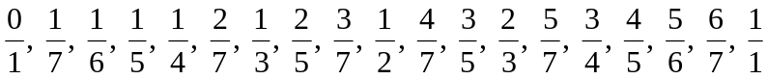
Note that there are 19 terms in this series.

Let 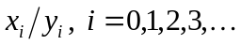, be the Farey series of order n. It can be shown that

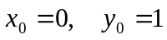
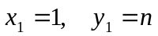
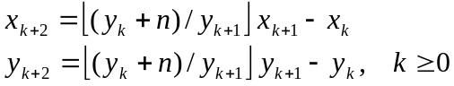

The total number of terms in the series is approximately 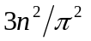.
Given an integer n ≥ 1, generate and count the number of terms in the Farey series of order n.

Input
The input consists of multiple datasets, followed by a line which contains only a single ‘.’ (period). Each dataset consists of a single line which contains an unsigned integer. Each unsigned integer is greater than zero and less than or equal to 100 (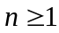and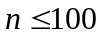).

Output
For each input dataset, print a line which shows the number of generated terms. Next, print the all terms in the Farey series of order n and any two adjacent terms are separated with space in a new line. Note that print a new line whenever the number of printed terms is times of 100.

Sample Input
3
7
9
.
Sample Output for the Sample Input
5 terms
0/1 1/3 1/2 2/3 1/1

19 terms
0/1 1/7 1/6 1/5 1/4 2/7 1/3 2/5 3/7 1/2 4/7 3/5 2/3 5/7 3/4 4/5 5/6 6/7 1/1

29 terms
0/1 1/9 1/8 1/7 1/6 1/5 2/9 1/4 2/7 1/3 3/8 2/5 3/7 4/9 1/2 5/9 4/7 3/5 5/8 2/3 5/7 3/4 7/9 4/5 5/6 6/7 7/8 8/9 1/1

All inputs are from stdin and outputs to stdout.

